Payment to FICF

Via Bank
For Switzerland
FICF – Foundation for Indian Children’s Future
Stockera 3, 3186 Duedingen
IBAN: CH13 8080 8008 3100 4933 1
Scan this QR code for payments from Switzerland
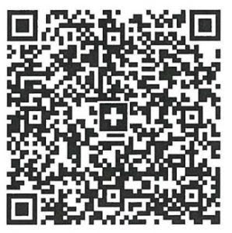
From other countries
Account Name: FICF – Foundation for Indian Children’s Future
Bank Name: Raiffeisenbank Freiburg Ost / Fribourg-Est
Account/IBAN : CH13 8080 8008 3100 4933 1
BIC/Swift Code: RAIFCH22XXX
Bank Address: Bahnhofplatz 1, 3186 Düdingen, Switzerland
Association Address: Stockera 3, 3186 Duedingen, FR, Switzerland

